Examine And Liberate

Project Report Submitted in Partial Fulfilment of the Requirements for the Degree of

**Bachelor of Engineering**

***in***

**Computer Science and Engineering**

*Submitted by*

Komal Kanwar Shekhawat (19UCSE4026)

Prashant Sharma(19UCSE4011)

***Under the Supervision of***

Dr. Alok Singh Gahlot

Assistant Professor



Department of Computer Science and Engineering  
MBM University, Jodhpur

**June, 2022**

Examine And Liberate

Project Report Submitted in Partial Fulfilment of the Requirements for the Degree of

**Bachelor of Engineering**

***in***

**Computer Science and Engineering**

*Submitted by*

Komal Kanwar Shekhawat (19UCSE4026)

Prashant Sharma(19UCSE4011)

***Under the Supervision of***

Dr. Alok Singh Gahlot

Assistant Professor



Department of Computer Science and Engineering  
MBM University, Jodhpur

**June 2022**

 **Department of Computer Science & Engineering**

**M.B.M . University**

**Ratanada, Jodhpur, Rajasthan, India –342011**

**CERTIFICATE**

This is to certify that the work contained in this report entitled **“Examine and Liberate**” is submitted by the group members Ms. Komal Kanwar Shekhawat (Roll. No: 19UCSE4026) and Mr. Prashant Sharma (Roll No:19UCSE4011) to the Department of Computer Science & Engineering, M.B.M. University, Jodhpur, for the partial fulfillment of the requirements for the degree of **Bachelor of Engineering** in **Computer Science Engineering**.

They have carried out their work under my supervision. This work has not been submitted elsewhere for the award of any other degree or diploma.

The project work in our opinion has reached the standard fulfilling the requirements for the degree of Bachelor of Engineering in Computer Science Engineering in accordance with the regulations of the Institute.

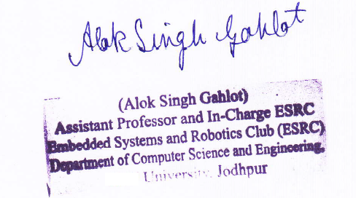

**Dr. Alok Singh Gahlot**

**Professor**

**(Supervisor)**

Dept. of Computer Science & Engg.

M.B.M. University, Jodhpur

**Dr. Nemi Chand Barwar**

**(Head)**

Dept. of Computer Science & Engg.

M.B.M. University, Jodhpur

**DECLARATION**

We, ***Prashant Sharma and Komal Kanwar Shekhawat,***hereby declare that this seminar/project titled **“Examine and Liberate”** is a record of original work done by us under the supervision and guidance of ***Dr.*** ***Alok Singh Gahlot***.

We further certify that this work has not formed the basis for the award of the Degree/Diploma/Associateship/Fellowship or similar recognition to any candidate of any university and no part of this report is reproduced as it is from any other source without appropriate reference and permission.

SIGNATURE OF STUDENT SIGNATURE OF STUDENT

**Komal Kanwar Shekhawat Prashant Sharma**

**8th Semester, CSE 8th Semester, CSE**

Enroll. - 18R/33036 Enroll. - 18R/06194

Roll No. - 19UCSE4026 Roll No. - 19UCSE4011

**ACKNOWLEDGEMENT**

I would like to place on record my deep sense of gratitude to Prof. Dr. Nemi Chand Barwar, HOD-Dept. of Computer Science and Engineering, M.B.M University, Jodhpur, for the successful completion of the seminar.

I express my heartfelt gratitude to my project guide Dr. Alok Singh Gahlot for his valuable guidance and suggestions in the preparation of the seminar report.

I will be failing in duty if I do not acknowledge with gratitude thanks to my project mentor Asst. Prof. Abhisek Gour and the authors of the references and other literature referred to in this seminar. A great thanks to my team member.

**ABSTRACT**

For many years land and water transports were used in various spheres of life but there are situations in today’s life where air transport is a must, one such situation is the disaster. The aim of the project is to replace the manned aerial rescue operation and make them fully automatic.

Robotics is always a better way to implement things on a smaller scale with great accuracy. Opting on robotics to visualize the whole problem situation of the real world is always a great choice. Hence to replace the manned aerial vehicles drones is chosen as the hero of the project which would rescue people in disaster. This drone will also provide medical and food facilities at the areas where required.

The project visualizes the whole disaster situation in the form of a model which can be worked upon in a room. The disaster area is represented with the arena’s white portion and the houses to be rescued are represented in the form of black boxes. The drone is always positioned at a base station and in case of the disaster the beacons are lit by people living in the houses in the form of beacons. The overhead camera views the whole scene and detects the colours glowing at different areas or houses. According to the priorities of the task the drone is now commanded to provide services at different places.

**Contents**

| **Introduction** | **2** |
| --- | --- |
| * 1. Motivation.……… ……………………………………….. | **2** |
| 1.2 Flow of the project…………………………………………. | **3** |
| **Technologies, Hardware & Software** | **5** |
| 2.1 Technologies………………………………………………. | **5** |
| 2.2 Hardware…………………………………………………... | **6** |
| 2.3 Software……………………………………………..……. | **9** |
| **Project Details** | **13** |
| 3.1Major Sub-Portions of the project | **13** |
| 3.1.1 Working in Gazebo Environment…………………… | **13** |
| 3.1.2 Position hold in real World……………………………… | **14** |
| 3.1.3 Saving of Coordinates……………………………… | **15** |
| 3.1.4 Region of Interest…………………………………… | **15** |
| 3.1.5 Testing and working with beacons…………………. | **16** |
| 3.1.6 Detecting Colours of the Beacons…………………… | **16** |
| 3.1.7 Scheduler Algorithm………………………………… | **17** |
| 3.2 Working of the project…………………………………… | **19** |
| **Results** | **22** |
| **Conclusion & Future Work** | **24** |
| **References**…………………………………………………………… | **26** |

**List of Figures**

| 2.1.2 PID Control System……...……………………………………………… | 3 |
| --- | --- |
| 2.1.4 ROS …………. …………………………………………………………. | 4 |
| 2.2.1 PlutoX….………………………………………………………………... | 5 |
| 2.2.2 Whycon Markers………………………………………………………... | 5 |
| 2.2.3 Flex Sheets………………………………………………………………. | 6 |
| 2.2.4 LED Strips…… …………………………………………………………. | 6 |
| 2.2.5 Arduino Nano……………………………………………………………. | 7 |
| 2.2.6 Rooftop Camera…....…………………………………………………… | 7 |
| 2.3.1 Gazebo World…………………………………………………………… | 8 |
| 2.3.3 Guvcview………………………………………………………………... | 8 |
| 2.3.9 Plotjuggler……………………………………………………………….. | 9 |
| 3.3.1 Drone Motion…………………………………………………………….. | 12 |
| 3.3.2 /whycon/image_out………………………………………………………. | 12 |
| 3.1.4 Region of Interest………………………………………………………… | 14 |
| 3.1.6.1 Beacons………………………………………………………………… | 15 |
| 3.1.6.2 Colours detected……………………………………………………….. | 15 |
| 3.2 Working of the project…………………………………………………….. | 17 |
| 4.1 Results…………………………………………………………………….. | 20 |

**List of Tables**

| 1. Important Ros Topics………………………………………………………... | 16 |
| --- | --- |

**Chapter 1**

**INTRODUCTION**

Drones offer benefits in many sectors like infrastructure, surveillance, agriculture, mining, emergency response, law enforcement, transportation, defence, geo-spatial mapping, etc.

* 1. **Motivation**

Often after natural disasters or terrorist attacks, infrastructure supply lines are cut and disabled. When roads, bridges, communication cables and gas and water lines are compromised, the safety of residents in the area is also compromised. To mitigate suffering and further damage, rescue teams can utilize drones to support infrastructures, deliver supplies and establish communication. In areas that are nearly impossible to reach, drones can deliver supplies such as water and food to those in need, eliminating the risks of placing human-operated aircraft in harm’s way.

Due to the reach and versatility of drones, significant employment opportunities can be created in remote areas too. Drones have received mixed criticism because of their associations with invasion of privacy and with their armed deployment in war. There is another more positive use that provides safety, protection and relief from disasters. Natural and man-made disasters destroy environments, often making conditions so difficult that relief workers are unable to access areas and provide assistance. Drones have the ability to take on roles where relief workers and manned vehicles fall short. Thinking of the emergency situation of disaster where robots can assure safety in maximum conditions. Also the robots can be fast enough in any situation. Robots are able to produce incredibly accurate, consistent, and high-quality work without needing breaks or holidays off. Looking at the advantages of replacing humans with robots the project ideologized.

* 1. **Flow of the Project**

In order to replace the helicopters used in real life for the search and rescue operations, here a drone named plutoX quadcopter is to be used. The drone does not have an on-board camera on it. For the localization of the drone in a disaster-prone area whycon markers will help. The PID (Proportional Integral Derivative) control system mechanism will help in drone motion and positioning. To create an artificial disaster-prone area a 8x8 feets flex sheet fulfills the purpose. The flex sheet has 36 black boxes representing the houses to be liberated with a white background representing the disaster around it. Hence to find the area to be rescued image processing is to be used to find the region of interest and provide services. As people in need of immediate help ask for help using some indicators known as beacons, these beacons are made using the LED modules. In order to process the LED modules Arduino nano will be used. Red LED represents liberation of the person which is treated as the highest priority, blue LED represents the medicinal help, yellow LED represents the food requirement both having same priorities. In order to visualize the whole scene of the disaster, an overhead camera will be employed at a height of 8-10 feet’s from the ground.

Flow of the project is such that for the beacon will light up in pseudo-random fashion. At that point the drone is positioned at the base station. This scene is viewed using the overhead camera. The camera by using image processing detects the beacons. As a result the ROS messages are published on a topic. This information is used to make the decision regarding the rescue operations to be performed.

**Chapter 2**

**Technologies, Hardware and Software**

**2.1 Technologies**

* **Image Processing**

Image processing is a method to perform some operations on an image, in order to get an enhanced image or to extract some useful information from it. The project uses this to detect the region of interest, to capture the coordinates of the different areas A1, B1……F6. Mainly used to detect the colours of beacons.

* **Control System**

A control system manages, commands, directs, or regulates the behavior of other devices or systems using control loops. PID (proportional integral derivative) controllers use a control loop feedback mechanism to control process variables and are the most accurate and stable controller. PID is applied to maintain the position of the drone at a particular point.

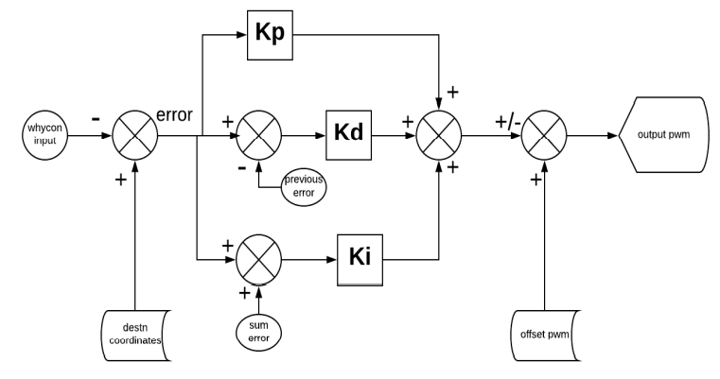

Fig 2.1.2 PID Control System

* **Algorithm Development**

Algorithm development is the act of designing the steps that solve a particular problem for a computer or any other device. Scheduling of the tasks is the major problem of the project and the solution to that is obtained by developing an algorithm for prioritizing the work to be performed by the drone.

* **Robot Operating Systems**

Robot Operating System is an open-source robotics middleware suite. Although ROS is not an operating system but a set of software frameworks for robot software development. The whole project is done using ROS. It has a set of software libraries and tools that help in building robot applications, from drivers to algorithms.



Fig 2.1.4 ROS

**2.2 Hardware**

* **PlutoX Liberation-copter**

PlutoX is the most agile and modular aerial platform meant for accelerated development on nano-drones. It comes with Modular hardware, Modular Software, Firmware SDK, App SDK, Open-source (3d printable) frames. Features are Flight Time: 9 mins, Payload: 15g, SDK: API Based interface, Communication: WiFi (60m), Frame: Open Source and Modifiable.

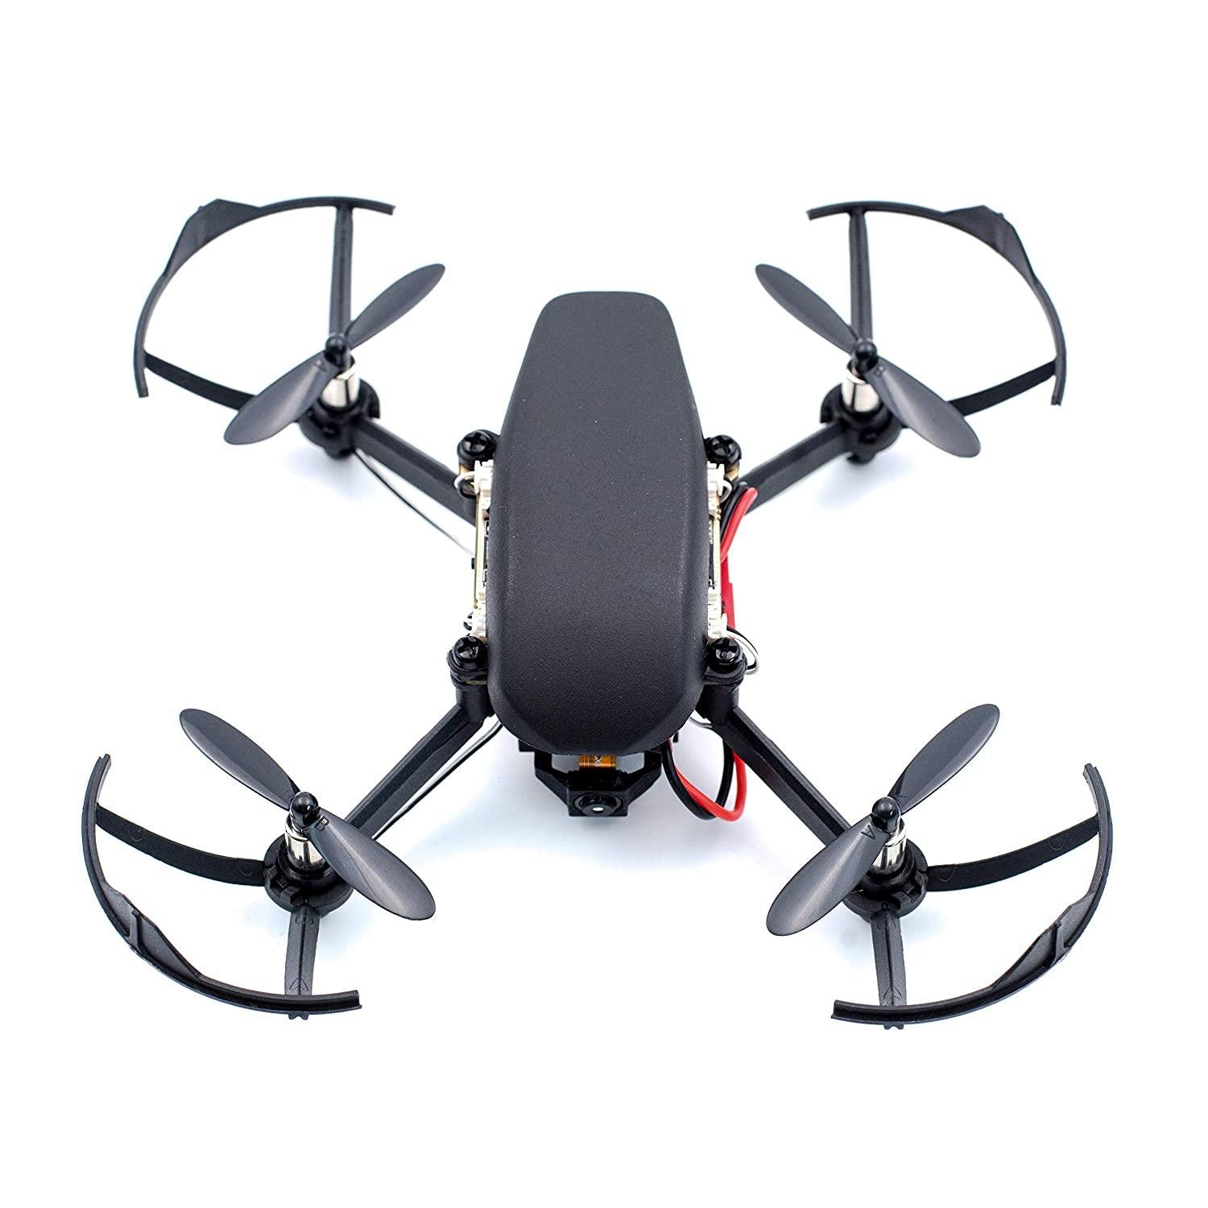

Fig 2.2.1 Pluto-X

* **Whycon markers**

WhyCon is a version of a vision-based localization system that can be used with low-cost web cameras, and achieves millimetre precision with very high performance. These are used to localize the drone at any position on the arena.



Fig 2.2.2 Whycon Marker

* **Flex Sheet**

An 8x8 feet flex sheet with 36 black squares of 18cmx18cm on a white background represent the houses affected in disaster situations.

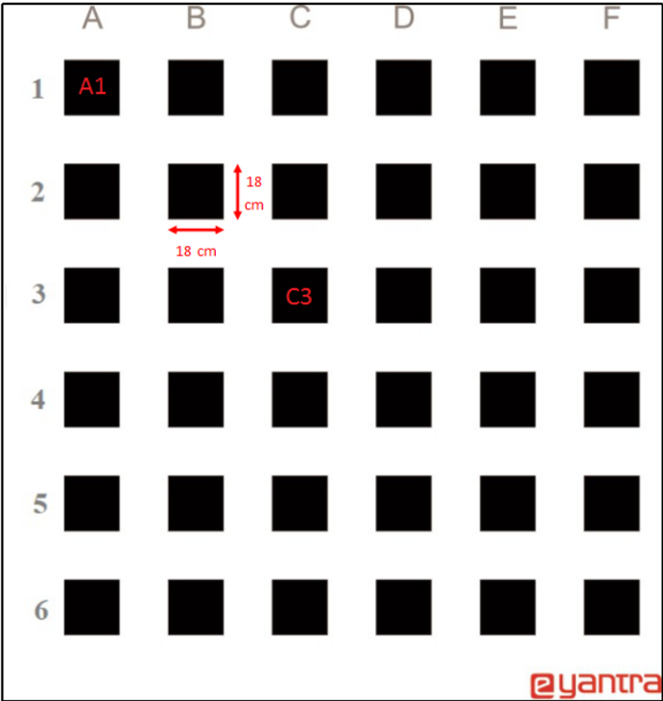

Fig 2.2.3 Flex Sheet

* **Led Modules or Beacons**

Each LED module had 4 LEDs connected in series. Each LED module has 2 end wires to connect top the previous and the next module. The first LED module is connected to the DC jack and then to the arduino.

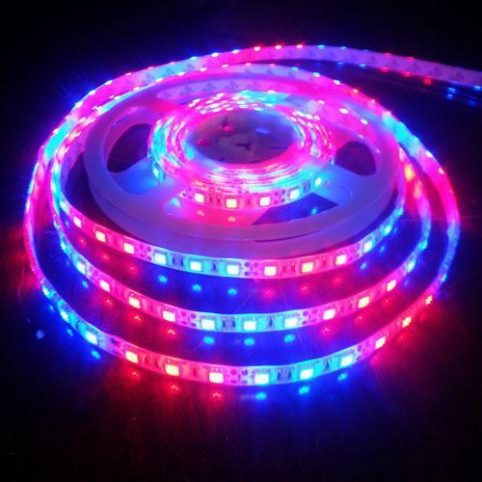

Fig 2.2.4 LED Strips

* **Arduino nano**

It is used to produce a clock of precise frequency using constant voltage. There is one limitation of using Arduino Nano i.e., it doesn't come with a DC power jack, which means you cannot supply an external power source through a battery.

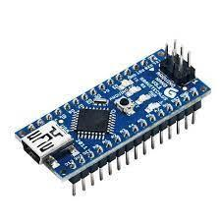

Fig 2.2.5 Arduino nano

* **Rooftop Camera**

Camera is used to view the scene and apply the image processing on it. It was placed at a height of about 10 feet from the ground. Although the image percieved by the camera on the laptop seems to have some position error but in the real world it does not have that much error.

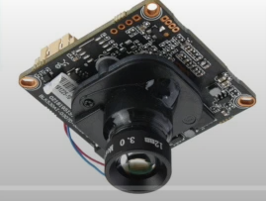

Fig 2.2.6 Rooftop Camera

**2.3 Software**

* **Gazebo**

Gazebo is a powerful robot simulator used by industry and academia that calculates physics, generates sensor data and provides convenient interfaces. Open-source software is lowering the barrier to entry and speeding up progress in robotics.

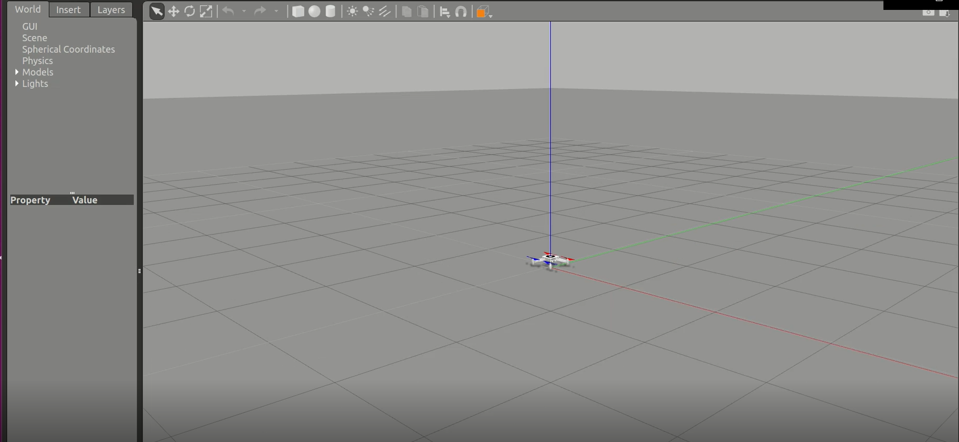

Fig 2.3.1 Gazebo World

* **VSCode**

Used as the code editor.

* **guvcview**

Guvcview is a webcam application, i.e., software to handle UVC streams, for the Linux desktop.

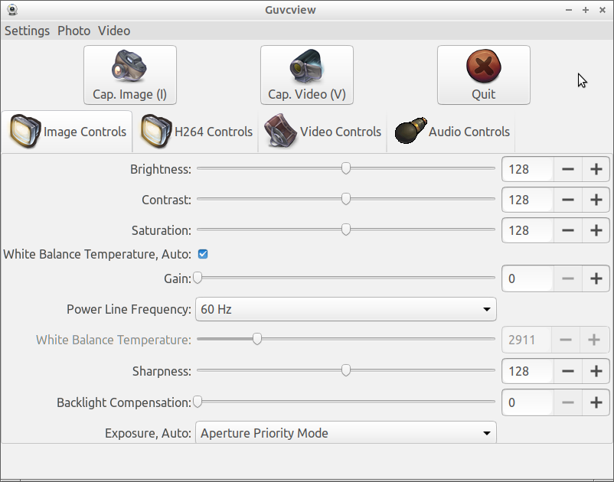

Fig 2.3.3 Guvcview

* **Arduino IDE**

Arduino Software (IDE) - contains a text editor for writing code, a message area, a text console, a toolbar with buttons for common functions and a series of menus. It connects to the Arduino hardware to upload programs and communicate with them.

* **Plot Juggler**

Fast intuitive and extensible time series visualization tool. Plotjuggler can be connected to an external application using any inter-process communication and display data in real-time. We used this tool to analyse the PID parameters of the drone while the drone was flying in the real world. The graphical representation of the roll, pitch and yaw errors helped us to visualize and take proper actions after that.

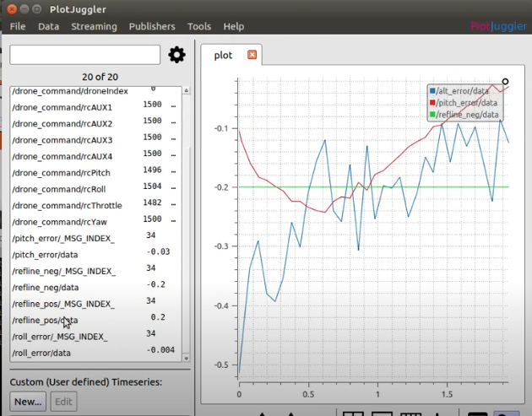

Fig 2.3.5 Plotjuggler

**Chapter 3**

**Project Details**

**3.1 Major sub portions of the project**

**3.1.1 Position hold in Gazebo Environment**

Before implementing the whole project in the real world, basic operations of holding the drone at a particular position in the gazebo world are formed. Tasks performed in the gazebo world were tuning of the PID according to the gazebo world.

* Rosnodes
  + *position_hold_gazebo.py*
* Launch Files
  + *launch_gazebo_and_whycon. launch*
* Topics Subscribed
  + /whycon/poses
  + /pid_tuning_altitude
  + /pid_tuning_pitch
  + /pid_tuning_roll
* Topics Published
  + /drone_command
  + /alt_error
  + /pitch_error
  + /roll_error

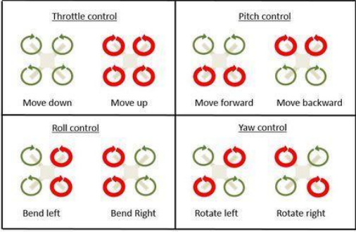

Fig 3.1.1 Drone Motion

**3.1.2 Position Hold in Real World**

Position holding in the real world required the PID tuning again to be done with the real hardware and also required to test and set up the environment. Hence the basic hardware testing for performing the task in the real world were: -

* Removing the fish eye effect of the camera: - This was carried out by calibrating the camera with the help of the calibration file and some hardware.
* Learning to drive, stop and calibrate the drone: - This was carried out by installing the plutoX app in the mobiles and calibrating the drone. Moreover we even practiced driving and landing the drone safely.

The files involved in running the drone were the same as previous.

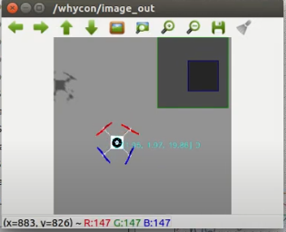

Fig 3.1.2 /whycon/image_out

**3.1.3 Saving the coordinates**

To drive the drone at different positions, providing the drone with the coordinates is never a great choice. As this could be replaced with a method of providing the drone with the input of the names mentioned in the flex sheet i.e. A1, A2, A3… F6.

This could be achieved by making a JSON file containing all the coordinates of the points, which could be accessed every time we command the drone to move at a position.

* Rosnodes

## *capture_cell_coordinates.py*

* Resulting JSON file
  + *cell_coords. json*

**3.1.4 Region of Interest**

As now the drone is able to move to all the points on the flex sheet with the help of the names mentioned on the sheet due to the formation of the JSON file. Now the next step to be carried out is to find the region of interest which should be looked upon while detecting the colour of the LED glowing at that box.

These ROIs will be used during the liberation of the people during a disaster. This required the basic knowledge of image processing using OpenCV library.

Basic steps involved in performing this are: -

1. Standard pre-processing on the input image: -
   1. Blur the image
   2. Sharpen the image
   3. Thresholding
   4. Get the image with 4 sides
2. Find contour and filter threshold area using findContours and drawContours functions.

* Rosnodes

## *roi_detector_boilerplate.py*

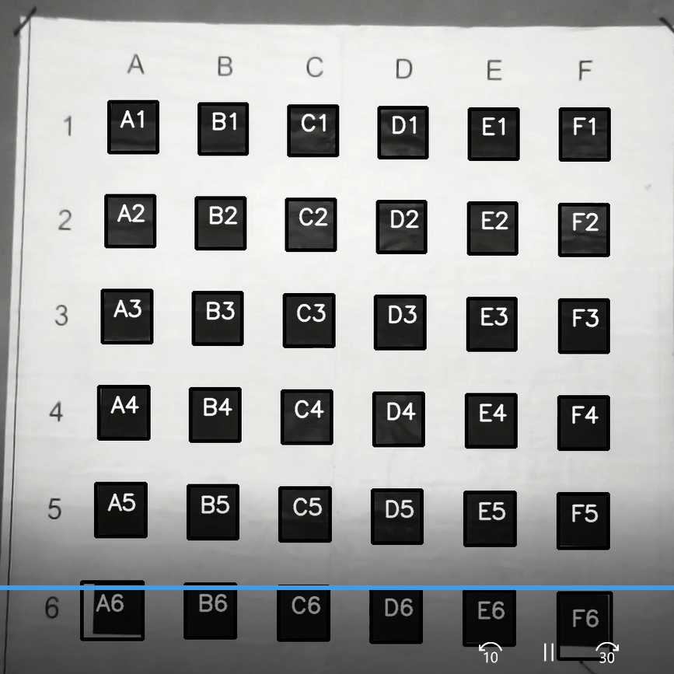

Fig 3.1.4 Region of Interest

**3.1.5 Testing and working with beacons**

Testing the beacons is a vital task to be done in order to proceed further the steps involved in this were:

1. Specify the port to which the arduino will be connected to and provide the access to that port.
2. Burn the hex file to the arduino according to which the beacons would glow.
3. Start the rosserial node.

The result was that all the beacons glow as mentioned in the hex file.

**3.1.6 Detecting Colours of the Beacons**

Next step towards the completion of the project required the correct detection of the colour of the beacons. This was again done with the help of image processing and the OpenCv library of python.

* Rosnodes

## *beacon_detector.py*

* Launch Files
  + *detect_beacons. launch*
* Subscribers
  + */usb_cam/image_rect_color*
  + */serviced_info*
* Publishers
  + */detection_info*

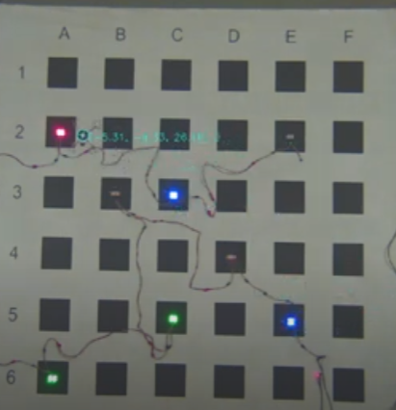

Fig 3.1.6.1 Beacons

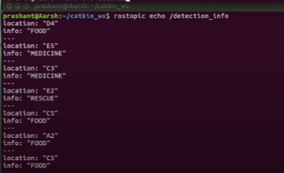

Fig 3.1.6.2 Colours detected

**3.1.7 Scheduler Algorithm**

**WORKING**

To develop the algorithm the basic things we referred were: -

1. Select the base position from the .tsv file we are referring to.
2. Create the individual dictionaries of the beacons with their respective coordinates, for all the three conditions of rescue, medicine and food.
3. To give highest priority to the rescue operation and then choose anyone among the medicine and food.
4. If the medicine and food both are in demand then check the distance of the beacons and select the one with the least distance.
5. An array is made which contains the coordinates to be hovered by the drone. If the beacon on which the drone is hovering turns off then that coordinate is removed from this array.
6. At the same time the particular beacon which turns off is also removed from their individual dictionaries.

* Rosnode
  + *scheduler.py*
* Subscribers
  + /detection_info
  + /serviced_info
* Publishers
  + decision_info

**3.1.8 Main Rostopics**

| 1. /usb_cam_image_raw | USB camera basic image is viewed |
| --- | --- |
| 1. /usb_cam/camera_info | Camera information |
| 1. /usb_cam/image_rect_color | Coloured image with of specified size |
| 1. /whycon/poses | Detect the position of the whycon |
| 1. /whycon/image_out | Write that position in the image to be viewed |
| 1. /drone_command | Commands the drone about yaw, pitch & roll |
| 1. /led_control_topic | Controls the LED |
| 1. /detection_info | Detect the colour of the beacons |
| 1. /serviced_info | Contains information about serviced beacons |
| 1. /decision_info | Decides which beacon should be processed |

Table 1: Important Ros Topics

**3.2 Working of the project**

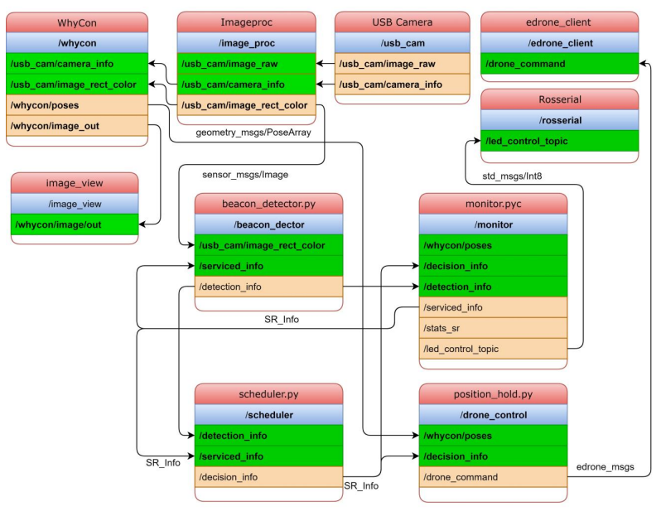

Fig 3.2 Working of the project

1. Starting from the USB Camera node which publishes the raw image in our case the disaster-prone area.
2. The topics published by the USB Camera are now published by the image proc node and as a result publishes a colourful rectangle image of the disaster-prone area.
3. This next step is to identify the location of the whycon kept in the disaster area. This is made successful with the help of the whycon node, with the help of the topics published by the image proc node. Major work of the whycon node was its publications of whycon position and the whycon image.
4. This whycon image which now contains the coloured rectangular view of the disaster area and the whycon position is now viewed by the image_view node.
5. monitor.pyc node is the one which glows the beacons in some fashion by publishing on led_control_topic. This node has all the information about the detected beacons (by beacon_detector.py), the decision to be taken to liberate the beacon(by scheduler.py). Hence it lights up the beacons and monitors the activity of beacons and liberation.
6. Once the beacons are lit the beacon_detector.py detects the beacons correctly and publishes to the /detection_info topic so this topic contains that in which region which service is required.
7. Now, the scheduler by looking at the serviced info and the detection info takes the decision and publishes the decision about which beacon to be serviced first.
8. This information from the decision topic of the scheduler is now used by the position hold node. It takes a note of the drone position with the help of the whycon. It publishes the drone command that contains the yaw pitch and throttle values, on which the drone will run.
9. edrone_client node publishes this topic about the drone command and makes the drone fly to the desired position as calculated by the scheduler algorithm.

**Chapter 4**

**Results**

* The emergency situation of the disaster was handled with great accuracy. The drone had a great control system which made it move at various positions swiftly. The values of PID were perfectly set.
* The camera properties were set in such a way that they even detected the whycon and also the colour of beacons correctly.
* Scheduling algorithm worked properly and processed red/rescue first and then blue/medicine or green/food.
* The GitHub link for the project is <https://github.com/prash191/Examine_and_Liberate>
* The unlisted YouTube video of the project is at

<https://youtu.be/bmUh2NeEXkU>

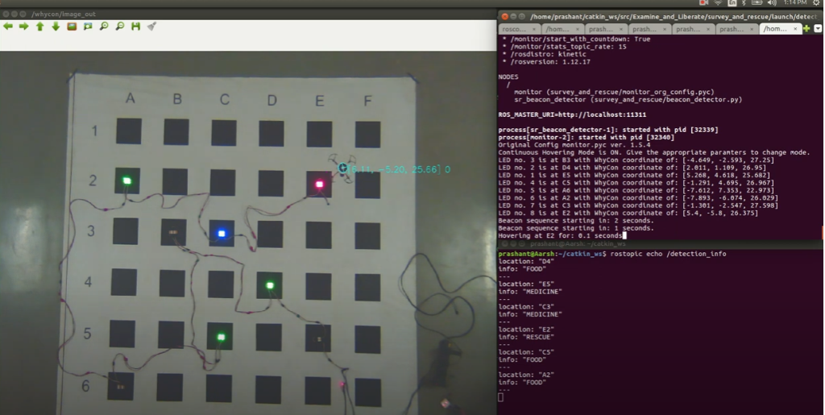

Fig 4.1 Result

**Chapter 5**

**Conclusion & Future Work**

1. **Conclusion**

* The project is a perfect implementation of the use of drones in a disaster-prone area.
* Viewing the disaster-prone area from a camera, with the whycon to detect the whycon position is the basic task done.
* Then capturing the region of interest A1 to F6 is implemented. Moreover the coordinates of the centre of these regions are stored in a JSON file.
* Glowing of beacons are handled by the monitor.py file.
* Detection of beacons is done and based on this the scheduler algorithm schedules the tasks.
* The coordinates to be visited to liberate the suffering people are done.

1. **Future Work**

* Try to get a better drone with an on-board camera on it and plan the path to be followed to supply the emergency facilities.
* Try to use the drone for mapping and planning.
* Get a drone which can hold payload and can deliver it.
* The result is observed to be slower and with some time investment in the project can become faster.

References

1. Qing-Guo Wang, Tong-Heng Lee, Ho-Wang Fung, Qiang Bi and Yu Zhang, "PID tuning for improved performance," in IEEE Transactions on Control Systems Technology, vol. 7, no. 4, pp. 457-465, July 1999, doi: 10.1109/87.772161.
2. Quigley, M., Conley, K., Gerkey, B., Faust, J., Foote, T., Leibs, J., ... & Ng, A. Y. (2009, May). ROS: an open-source Robot Operating System. In *ICRA workshop on open source software* (Vol. 3, No. 3.2, p. 5).
3. Culjak, I., Abram, D., Pribanic, T., Dzapo, H., & Cifrek, M. (2012, May). A brief introduction to OpenCV. In *2012 proceedings of the 35th international convention MIPRO* (pp. 1725-1730). IEEE.
4. Xie, G., & Lu, W. (2013). Image edge detection based on opencv. *International Journal of Electronics and Electrical Engineering*, *1*(2), 104-106.
5. Nitsche, M., Krajnik, T., Cizek, P., Mejail, M., & Duckett, T. (2015). WhyCon: an efficient, marker-based localization system.
6. Meyer, J., Sendobry, A., Kohlbrecher, S., Klingauf, U., & Stryk, O. V. (2012, November). Comprehensive simulation of quadrotor uavs using ros and gazebo. In *International conference on simulation, modeling, and programming for autonomous robots* (pp. 400-411). Springer, Berlin, Heidelberg.
7. *Nagaty, A., Saeedi, S., Thibault, C., Seto, M., & Li, H. (2013). Control and navigation framework for quadrotor helicopters. Journal of intelligent & robotic systems, 70(1), 1-12.*
8. *Megalingam, R. K., Prithvi, D. V., Kumar, N. C. S., & Egumadiri, V. (2022). Drone Stability Simulation Using ROS and Gazebo. In Advanced Computing and Intelligent Technologies (pp. 131-143). Springer, Singapore.*
9. Understanding PID control <https://www.youtube.com/watch?v=wkfEZmsQqiA>